Project Description:
According to a study from the Department of Education (2019), academic pressures take and class relationships up 74% of the main issues as to why Filipino students feel stressed out. An essential part of the curriculum requires on assignments, activities, and tests. A research paper from the Second Congressional Commission on Education (N/A) also suggests the curriculum’s design overwhelms Filipino students, stating excessive instructional hours and lack clear homework guidelines, leading to overwork by design. The results from National Library of Medicine (2024) does give positive remarks on academic-based reminder apps, but also states that students can grow dependent of these reminders over time. A needed requirement is to make sure study apps are not addicting, so they won’t cause dependence of students.

Project Objectives and Features:
We aim to use the Agile methodology to build our app incrementally. Because our scheduler is already divided into different parts. So modularizing our code and developing it in sprints would be best for our time management as scholars.
Specific Design Features To help in alleviating friction from tasks, the app will be a scheduler, featuring:
• Adding a task / Removing it: this will be a core feature to our code that makes it easy to quickly input necessary tasks and erase the unimportant.
• Prioritization Algorithm: A behind the scenes that processes user inputs and automatically sorts them into an organized list, ranked from most important to least.
• Two Display Options: A feature variation that allows users to view their schedule in a calendar form or standard list view.
Functional Testing & Validation Ensuring all features are fully functional and satisfactory before the final release, we will release prototypes and beta versions of the app to a group of testers. Gathering feedback from these cycles to ensure no bugs occur in the final product.

The requirements:
What we intend the code to do is that it will first display a menu bar that will welcome the user. It will then display a list of options. Those options will be the features mentioned earlier, which are the following:
1. Add,
2. Schedule,
3. List,
4. Check off task,
and 5. Exit code.
The user will have to input the number of their choice, and depending on the answer of the user, it will either request input and process, or output. For the add feature, it will require the user a date of requirement and the title of the activity. When the user complies, it will be directed back to the code and will be saved. It will then be displayed when the user chooses either the schedule feature or the list feature with the format being stated in the features part of this proposal. If an activity is finished, the user can then choose the check off task and remove the said task.

Sample Output:
class task:
def __init__(self,nt,wt,pt,dt,et):
self.nt = name
self.wt = what
self.pt = prio
self.dt = duedate
self.et = estt

def add_task(nt,wt,pt,dt,et):
new_slot=task(nt,wt,pt,dt,et)
task_manager.append(new_slot)

task_manager=[]
choice=0
while choice !=5:

print("Menu:\n 1. Add\n 2. Schedule\n 3. List\n 4. Check off task\n 5. Exit\n")
choice=int(input("Choice: "))

if choice==1:
name=str(input("Enter task name: \n"))
what=str(input("Type (Assignment, Project, Exam, Quiz): \n"))
prio=int(input("Priority-from lowest to highest (1-5): \n"))
duedate=int(input("Due in (days): \n"))
estt=int(input("Estimated minutes needed to finish: \n"))

add_task(name,what,prio,duedate,estt)

# beyond this is all TESTS.
index = task_manager[0]
print(index.nt)

Sample flowchart:
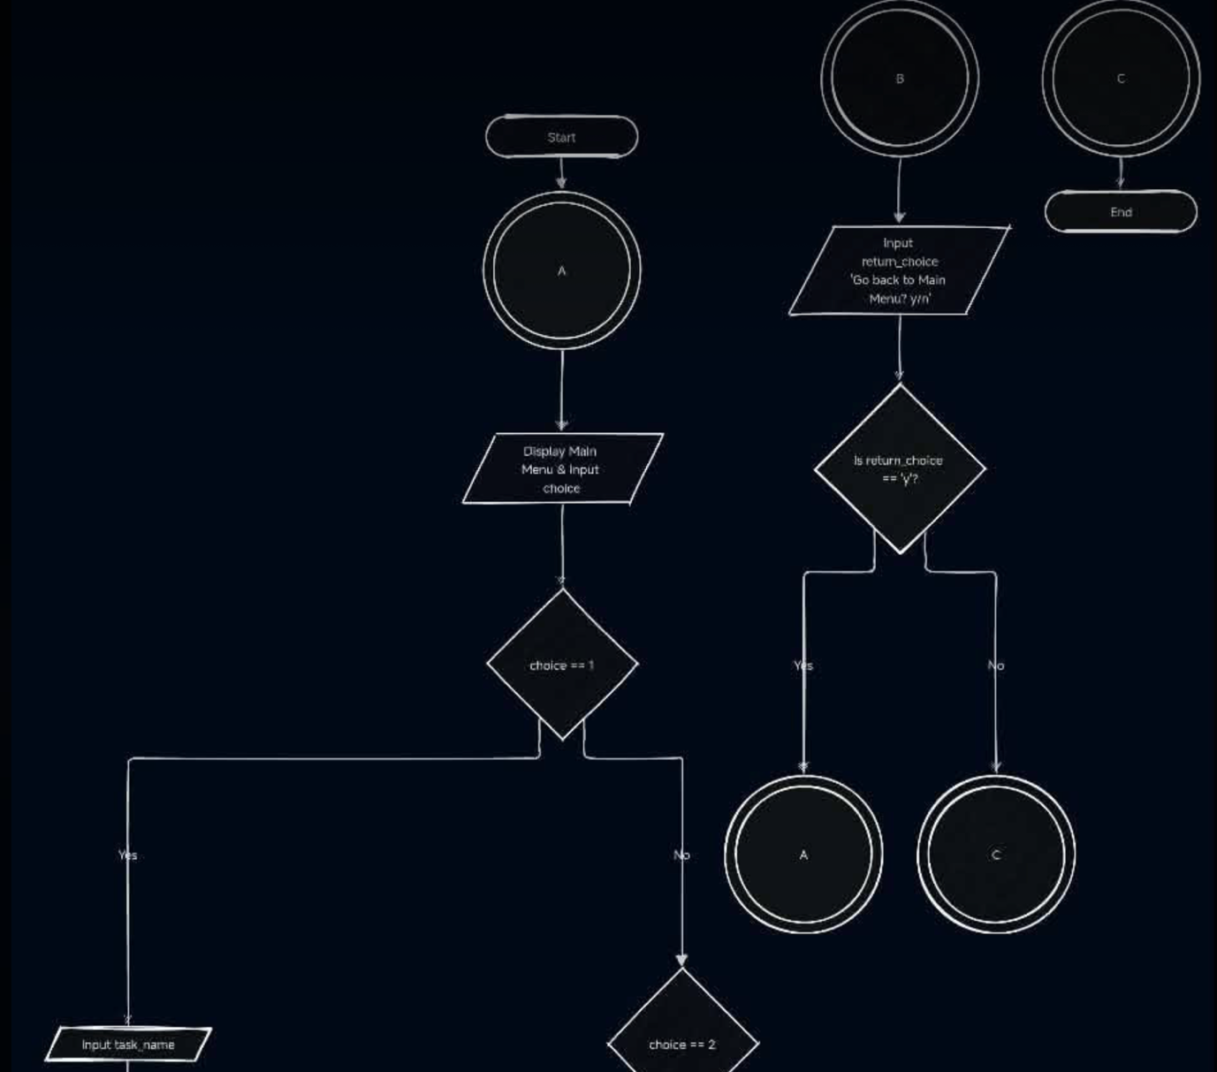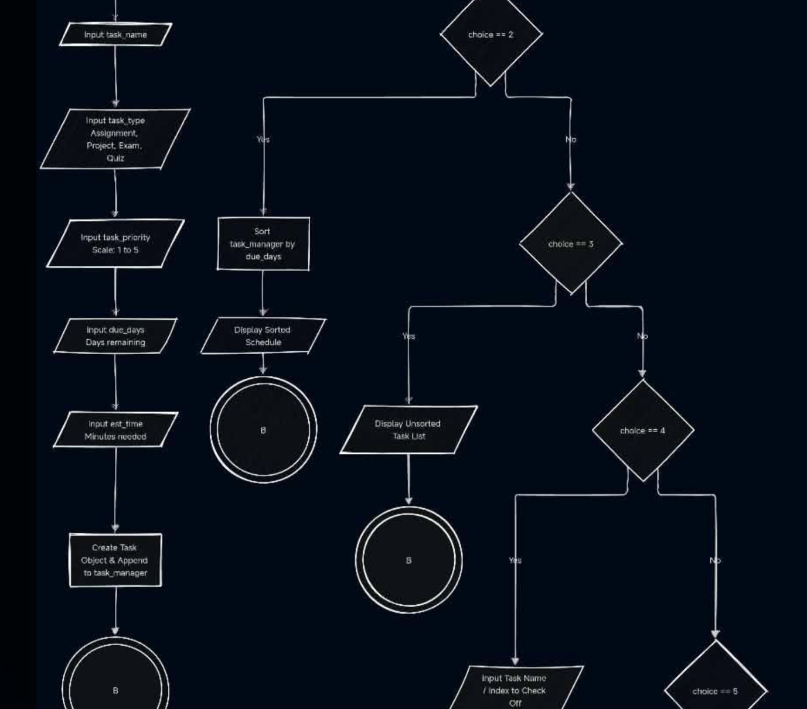

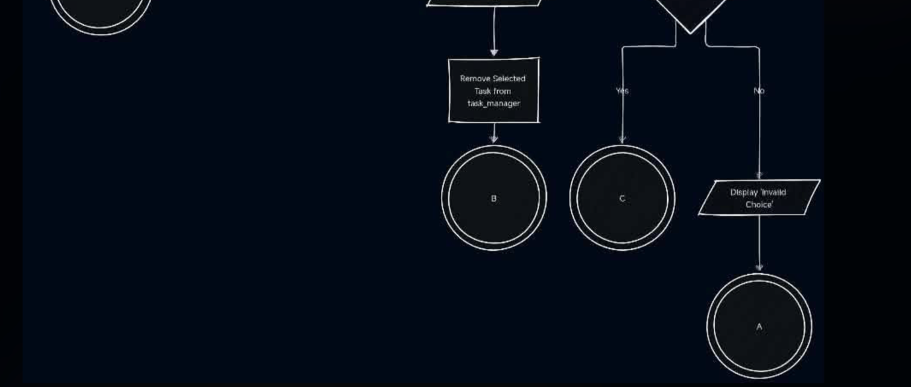

Contributions:
Name of Member: | Contribution:
Balledo, Erin | Main contributor of writing the Project Proposal
Coronel, Khent | Assisted in the sample code
Rivera, Reiyghn | Suggest what the code could be, provided the sample

